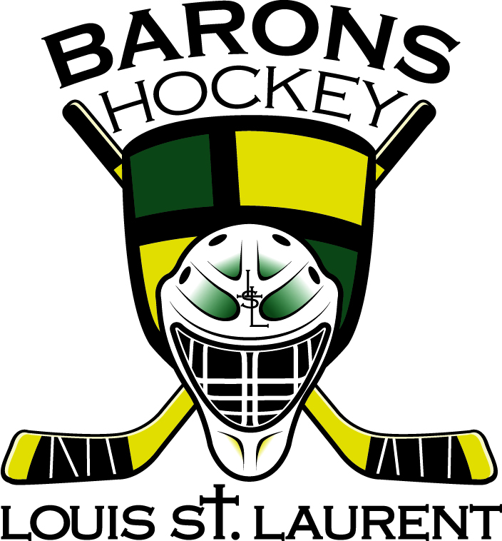
LOUIS ST. LAURENT BARONS HOCKEY ACADEMY
March 2013 Coach Message

“Success Happens ... when you develop the HABITS of mind that produce consistent EXECUTION of effective DECISIONS and ACTIONS.”

As Head Coach of the Academy and behalf on the coaching staff (Jaret, Dan, Jamie, Ian, Dave, Brian, Jason, Vanessa, Britney and Barry) the month of the Academy was very successful. Words I would use to describe the first month would be: fun, nerves, details, work ethic, focus, execution, respect and it’s a great day to be at the rink!

It has been a great start to the Hockey Academy in February. The coaches overall have been pleased with the players attitude, work ethic and detail to date. Over the course of February we have been focusing on puck handling with edge control work both in open and small area ice situations. Quantum Speed has been out on Wednesdays and have detailed proper stops/starts and stride length/frequency. Heading into March us coaches will move our focus to giving and (more importantly) receiving a pass. Passing is one of the weakest skills in Canada and a skill we must improve! Quantum speeds focus in March will be on turns & transitions and starts! We coaches are looking forward to more teaching, learning and FUN! Have a great weekend and GO CANADA!

Head Coach: Blair Becker

